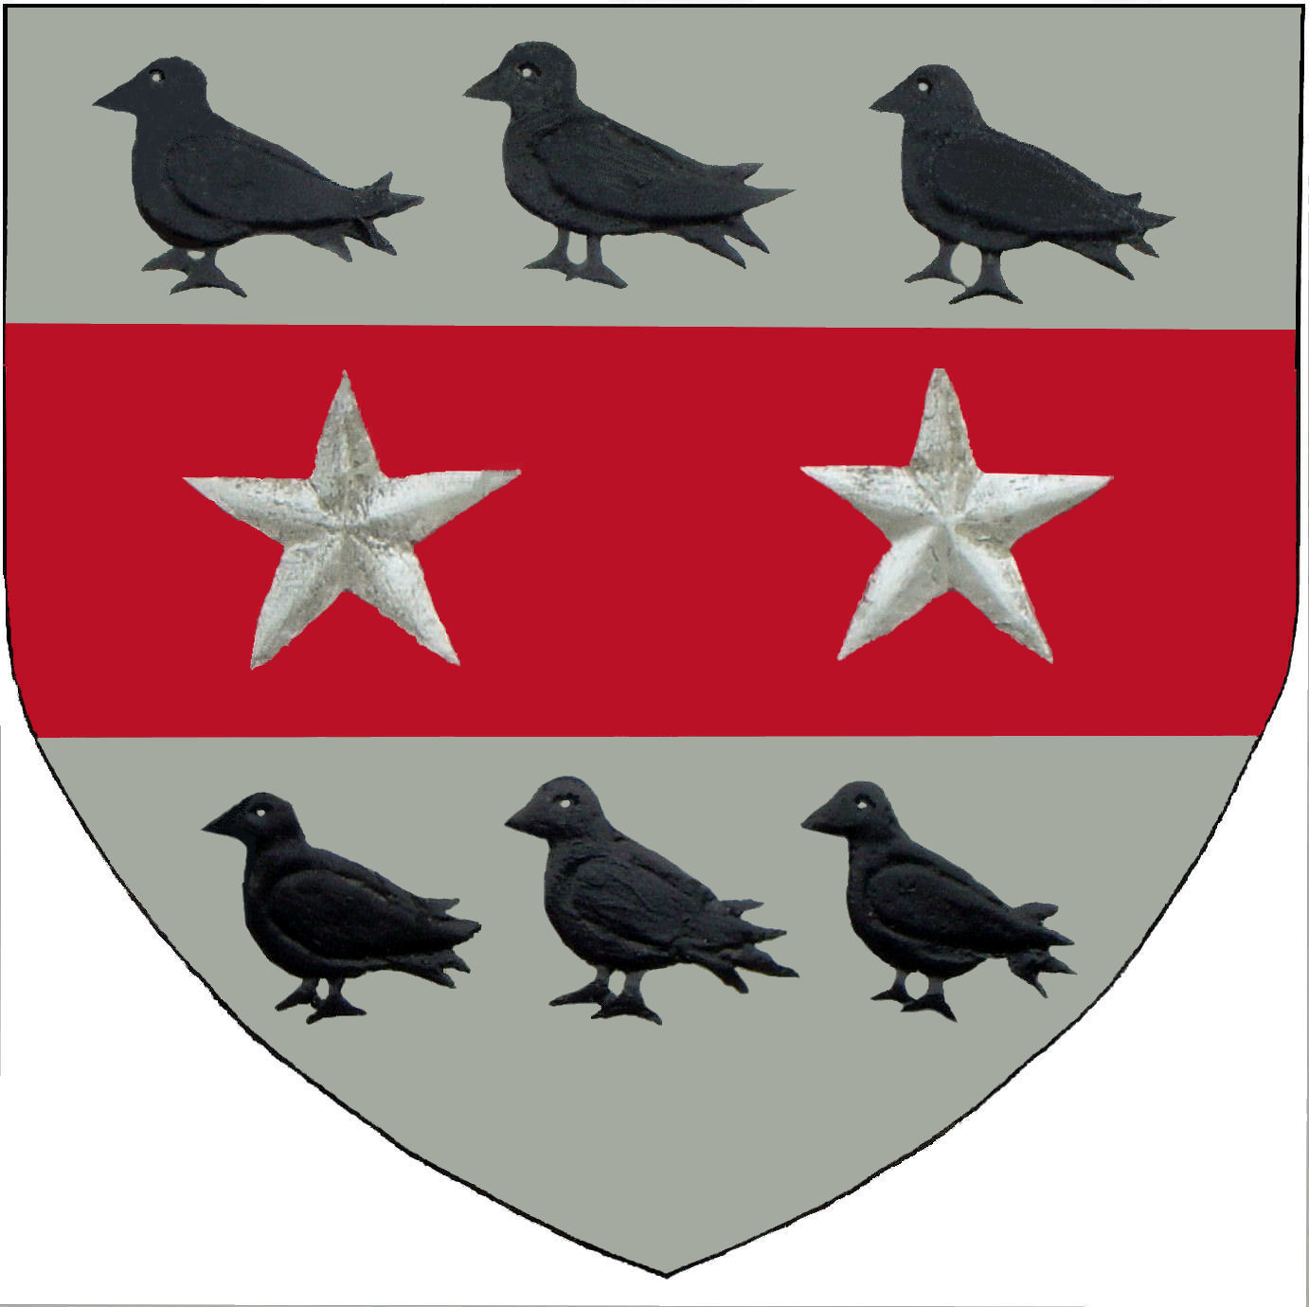
Layer Colts
YFC

Player’s Name ………………………………………… Team ……….. (e.g. U16s)

If you do not want your child to either be photographed by Layer Colts YFC, appear on the Layer Colts website or both then please sign and date this form and hand into your child’s Team Manager.

Any photographs taken by Layer YFC will be used by the Club and will not be distributed to any third party, with the exception of people viewing photographs from the LCYFC Website.

* I do not give permission for my child to be photographed by Layer Colts YFC **.

* I do not give permission for my child’s photograph to appear on the Layer Colts YFC website.

(Please delete either statement above if not applicable before signing)

Signature ……………………………………… Parent/Guardian

Date ……………………………………………

This form covers the player for the duration while signed to Layer Colts YFC.

** Please note Layer Colts YFC cannot stop anyone photographing or videoing on or in a public area/field

Issue 2 16-09-2010

